**Football Team Management**

DBMS project

**Sabrina Lupsan**

Faculty of Cybernetics, Statistics and Economic Informatics

Coordinating professor: Diaconita Vlad

Series G

Group 1064

**Description of the theme**

I chose to make a database of a Football Team and learned how to manage it. The players have four different kind of jobs, based on real-life evaluation and strategies – goalkeeper, midfielder, defender and attacker. The minimum and maximum salary of each job depend on the job and the net salaries were calculated using the gross salary and the taxes applied. Each team has players, a sponsor, matches played. The matches were played in different stadiums, and those stadiums are in different countries. This is how it all ties together, bringing the management of a Football Team. I believe that such a database is useful for storing data for official competitions like Champions League or The World Championship, which need official data, and for media news, who need statistics, such as the ones displayed in the exercises given. There are large volumes of data in this field because there are hundreds of matches per week all around the world.

All of the teams and names were fictious and the salaries chosen for this database are not official or true.

**1. The conceptual schema of the database**

A database always begins with a conceptual schema, which helps to design and organize the coding part. This also helps identify **the unique keys** (in bold), foreign keys, connections to other tables in the database and, eventually, errors.

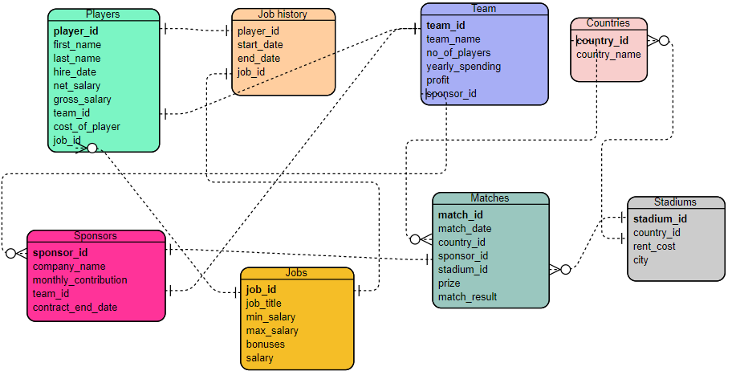

2. DDL and DML statements

--create table Players

BEGIN

EXECUTE IMMEDIATE

'CREATE TABLE Players

(

PLAYER_ID NUMBER(6, 0) PRIMARY KEY,

LAST_NAME VARCHAR2(50),

FIRST_NAME VARCHAR2(50),

HIRE_DATE DATE,

NET_SALARY NUMBER(6),

GROSS_SALARY NUMBER(6),

TEAM_ID NUMBER(6, 0),

COST_OF_PLAYER NUMBER(10, 2),

JOB_ID NUMBER(6, 0)

)';

END;

/

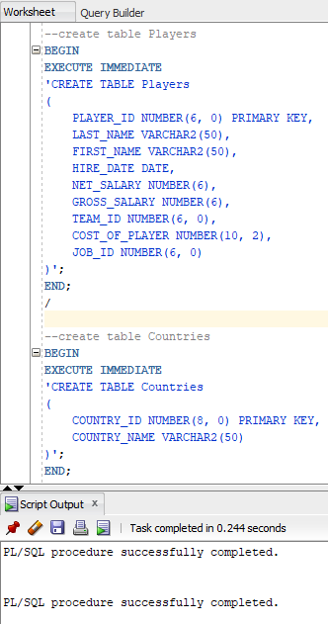

--create table Countries

BEGIN

EXECUTE IMMEDIATE

'CREATE TABLE Countries

(

COUNTRY_ID NUMBER(8, 0) PRIMARY KEY,

COUNTRY_NAME VARCHAR2(50)

)';

END;

/

--create table Stadiums

BEGIN

EXECUTE IMMEDIATE

'CREATE TABLE Stadiums

(

STADIUM_ID NUMBER(8, 0) PRIMARY KEY,

COUNTRY_ID NUMBER(8, 0),

RENT_COST NUMBER(5, 2),

CITY VARCHAR2(20)

)';

END;

/

--create table Team

BEGIN

EXECUTE IMMEDIATE

'CREATE TABLE Team

(

TEAM_ID NUMBER(6, 0) PRIMARY KEY,

TEAM_NAME VARCHAR2(100),

NUMBER_OF_PLAYERS NUMBER(3),

YEARLY_SPENDINGS NUMBER(8, 2),

PROFIT NUMBER(5, 2),

SPONSOR_ID NUMBER(5, 2)

)';

END;

/

--create table Jobs

BEGIN

EXECUTE IMMEDIATE

'CREATE TABLE Jobs

(

JOB_ID NUMBER(8, 0) PRIMARY KEY,

JOB_TITLE VARCHAR2(50),

MIN_SALARY NUMBER(8, 2),

MAX_SALARY NUMBER(8, 2),

BONUSES NUMBER(6, 2),

SALARY NUMBER(8, 2)

)';

END;

/

--create table Job_History

BEGIN

EXECUTE IMMEDIATE

'CREATE TABLE Job_History

(

JOB_ID NUMBER(8, 0),

START_DATE DATE,

END_dATE DATE,

PLAYER_ID NUMBER(8, 0)

)';

END;

/

--create table Sponsors

BEGIN

EXECUTE IMMEDIATE

'CREATE TABLE Sponsors

(

SPONSOR_ID NUMBER(8, 0) PRIMARY KEY,

COMPANY_NAME VARCHAR2(200),

MONTHLY_CONTRIBUTION NUMBER(6,2),

TEAM_ID NUMBER(6),

CONTRACT_END_DATE DATE

)';

END;

/

--create table Match

BEGIN

EXECUTE IMMEDIATE

'CREATE TABLE Match

(

MATCH_ID NUMBER(8, 0) PRIMARY KEY,

MATCH_DATE DATE,

COUNTRY_ID NUMBER(8,0),

SPONSOR_ID NUMBER(8,0),

PRIZE NUMBER(5, 0),

MATCH_RESULT VARCHAR(50)

)';

END;

/

--rename the table "Match" to "Matches"

BEGIN

EXECUTE IMMEDIATE

'ALTER TABLE Match RENAME TO Matches';

END;

/

--drop the column "FIRST_NAME" from the Players table

BEGIN

EXECUTE IMMEDIATE

'ALTER TABLE Players DROP COLUMN FIRST_NAME';

END;

/

--update the net salary of each player by deducting social (25%) and health (10%) insurance

--and the income tax (10%) from the gross salary

BEGIN

UPDATE PLAYERS

SET NET_SALARY = 0.9*(GROSS_SALARY - 0.35*GROSS_SALARY);

END;

/

--divide the players into 2 teams: players with the player_id in the interval [1, 2, 3, 4] are in the

--team with the id=5555 and players with IDs 5 and 6 are in the team with the team_id = 6666

BEGIN

UPDATE PLAYERS

SET TEAM_ID = 5555 WHERE PLAYER_ID IN (1, 2, 3, 4);

UPDATE PLAYERS

SET TEAM_ID = 6666 WHERE PLAYER_ID IN (5, 6);

END;

/

--Display in how much time the contract of every sponsor will expire, in intervals of: <1 year, 1-2 years, > 2 years.

SET SERVEROUTPUT ON

DECLARE

CURSOR end_date IS SELECT company_name,

(CASE

WHEN EXTRACT(YEAR FROM contract_end_date) - EXTRACT(YEAR FROM SYSDATE) < 1 THEN 'Less than 1 year'

WHEN EXTRACT(YEAR FROM contract_end_date) - EXTRACT(YEAR FROM SYSDATE) BETWEEN 1 AND 2 THEN 'Between 1 and 2 years'

ELSE 'More than 2 years'

END) YEARS

FROM Sponsors

ORDER BY (EXTRACT(YEAR FROM contract_end_date));

company end_date%rowtype;

BEGIN

OPEN end_date;

LOOP

FETCH END_DATE INTO company;

EXIT WHEN END_DATE%NOTFOUND;

DBMS_OUTPUT.PUT_LINE(COMPANY.COMPANY_NAME||' -> '||COMPANY.YEARS);

END LOOP;

CLOSE end_date;

END;

/

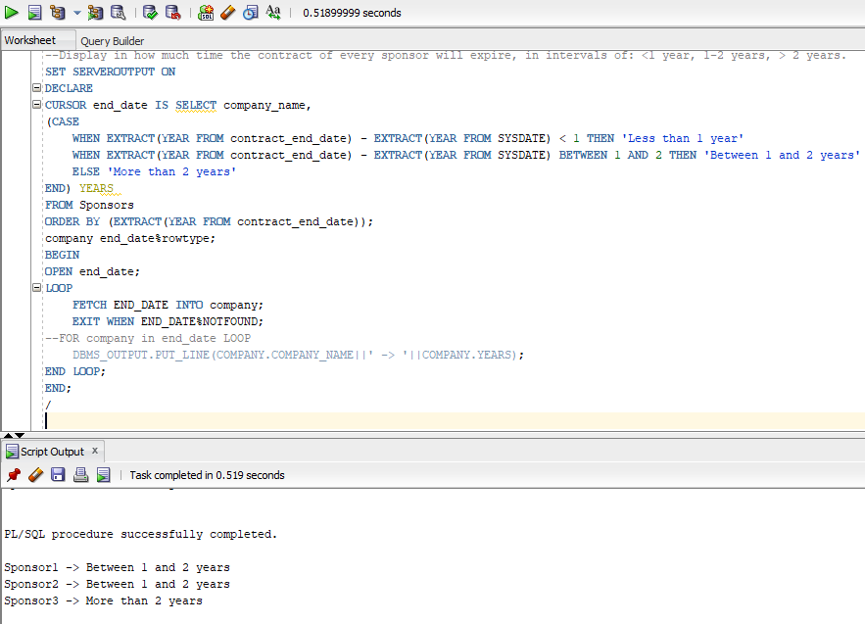

--compute the value of the net salaries that a team would have to pay if it would only have players with even IDs

SET SERVEROUTPUT ON

DECLARE

type player is record (

player_id number(8, 2),

net_salary number(10, 2)

);

v_player player;

v_total number(10, 0):=0;

v_players number(4, 0):=0;

BEGIN

SELECT COUNT(PLAYER_ID) INTO v_players FROM PLAYERS;

for i in 1..v_players loop

if i mod 2 = 0 then

select player_id, net_salary into v_player from players where player_id = i;

v_total := v_total + v_player.net_salary;

end if;

end loop;

dbms_output.put_line('The net salary of players with even player_id is: '||v_total);

end;

/

--display the name and player ID of the player in the 'Rangers' team. If there is more than one, print that

SET SERVEROUTPUT ON

DECLARE

v_name VARCHAR2(50);

v_id NUMBER(8);

BEGIN

SELECT last_name, player_id INTO v_name, v_id FROM PLAYERS WHERE TEAM_ID = (SELECT TEAM_ID FROM TEAM WHERE team_name = 'Rangers');

EXCEPTION

WHEN TOO_MANY_ROWS THEN

DBMS_OUTPUT.PUT_LINE('There is more than one player');

END;

/

SET SERVEROUTPUT ON

DECLARE

CURSOR CITIES IS SELECT STADIUM_ID, CITY FROM STADIUMS;

acity CITIES%ROWTYPE;

BEGIN

FOR acity in CITIES LOOP

OPEN CITIES;

DBMS_OUTPUT.PUT_LINE('Stadium '||acity.stadium_id||' is in: '||acity.CITY);

END LOOP;

EXCEPTION WHEN CURSOR_ALREADY_OPEN THEN

DBMS_OUTPUT.PUT_LINE('There was an error handling the cursor.');

END;

/

--Display the matches with the prize bigger than a given value dollars but exclude the ones in which the guest team did not win or they tied.

SET SERVEROUTPUT ON

DECLARE

CURSOR PRIZES(p_prize number) IS SELECT MATCH_ID, PRIZE, MATCH_DATE, MATCH_RESULT FROM MATCHES WHERE prize > p_prize;

v_prize prizes%rowtype;

BEGIN

FOR v_prize in prizes(10000) LOOP

if v_prize.match_result <> 'Host team lost' THEN

DBMS_OUTPUT.PUT_LINE(v_prize.match_id||' '||v_prize.prize||' '||v_prize.match_date||' '||v_prize.match_result);

END IF;

END LOOP;

END;

/

--display all jobs that have bonuses lower than 2000

SET SERVEROUTPUT ON

DECLARE

no_field exception;

pragma exception_init(no_field, -20101);

BEGIN

UPDATE Sponsors

SET sponsor_id = 0

WHERE company_name LIKE '%Oracle';

IF SQL%NOTFOUND = TRUE THEN

RAISE_APPLICATION_ERROR(-20101, 'No such sponsor found.');

END IF;

EXCEPTION

WHEN no_field THEN

DBMS_OUTPUT.PUT_LINE('No such sponsor found');

END;

/

--create a package

create or replace package player_pack_1 is

--display the number of players in a certain team

function get_no_players(v_team_id number) return number;

--Estimate the average amount of money a future player can win per month given the job_id

function average_salary(v_job_id number) return number;

--show the date of the match with a given id

function date_of_match(v_match_id number) return date;

--increase the salary of a certain player

procedure increase_salary(v_player_id number, v_percentage number);

--change the contract of ‘Sponsor2’ to end on the current date

procedure contract_ends(v_name string);

end;

create or replace package body player_pack_1 is

function get_no_players(v_team_id number) return number is

v_number number;

begin

select count(*) into v_number from players where team_id = v_team_id;

return v_number;

end;

function average_salary(v_job_id number) return number is

v_avg_salary number:=0;

begin

select round(((max_salary - min_salary)/2+bonuses)/12) into v_avg_salary

from jobs where job_id = v_job_id;

return v_avg_salary;

end;

function date_of_match(v_match_id number) return date is

v_date date;

begin

select match_date into v_date from matches where v_match_id = match_id;

return v_date;

end;

procedure increase_salary(v_player_id number, v_percentage number) is

no_player exception;

pragma exception_init(no_player, -20101);

begin

update players

set net_salary = net_salary + net_salary*v_percentage/100

where player_id = v_player_id;

if sql%notfound = true then

raise_application_error(-2101, 'There was no player found');

end if;

exception when no_player then

null;

end;

procedure contract_ends(v_name string) is

v_end date;

begin

select sysdate into v_end from dual;

update sponsors

set contract_end_date = v_end

where company_name = v_name;

end;

end;

set SERVEROUTPUT on;

begin

dbms_output.put_line('The number of players from the requested team is '||player_pack.get_no_players(5555));

dbms_output.put_line('The average monthly salary for the requested job is '||player_pack.average_salary(400));

dbms_output.put_line('The date of the requested match is '||player_pack.date_of_match(12));

player_pack.increase_salary(78, 5);

player_pack.increase_salary(3, 5);

player_pack.contract_ends('Sponsor3');

EXCEPTION

WHEN OTHERS THEN

dbms_output.put_line('Wrong data.');

end;

/

--create a trigger that doesn't allow a player to be in a different team than 5555 and 6666

CREATE OR REPLACE TRIGGER non_existent_team BEFORE INSERT ON PLAYERS for each row

BEGIN

IF :new.team_id not in (5555, 6666) then

raise_application_error(-20001, 'Wrong team ID');

end if;

END;

/

--to check if the trigger is triggered

INSERT INTO Players (PLAYER_ID, LAST_NAME, HIRE_DATE, NET_SALARY, GROSS_SALARY, TEAM_ID, COST_OF_PLAYER, JOB_ID) VALUES (90, 'Andrei', '19-NOV-2019', 9000, 9100, 100, 100000, 400);

--construct a trigger that won't allow you to input a hire_date that is in the future

CREATE OR REPLACE TRIGGER invalid_time BEFORE INSERT OR UPDATE ON PLAYERS for each row

BEGIN

IF :new.hire_date > sysdate then

raise_application_error(-20002, 'The date is not valid.');

end if;

END;

/

--to check

INSERT INTO Players (PLAYER_ID, LAST_NAME, HIRE_DATE, NET_SALARY, GROSS_SALARY, TEAM_ID, COST_OF_PLAYER, JOB_ID) VALUES (90, 'Andrei', '19-NOV-2021', 9000, 9100, 5555, 100000, 400);

**APEX part**

Link: <https://rpgzn0h8icu4sy6-sgbd.adb.eu-frankfurt-1.oraclecloudapps.com/ords/f?p=106:1:113874474989329:::::>

